I have accepted the offer, but the portal insist me on accepting it again.

Step 1 – Sign in with your username and password and click on “My Applications”

Step 2 – Click on “Accept/Decline Offer”.

*Note: When the offer is not accepted, the “Defer My Application” column will be empty.
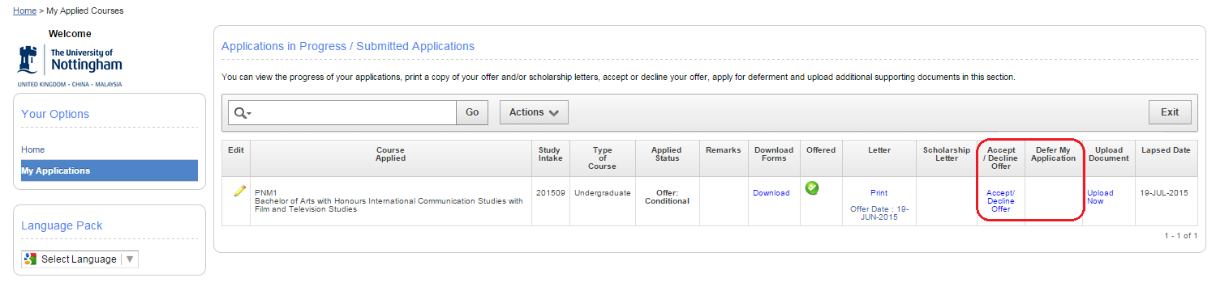
*Note 2: When the offer is accepted, the “Apply for Deferment” will appear under the “Defer My Application” column.
