**Agent Online Application:**

**For packaged offers:**

* Key in application as “Monash College Pathway” and choose the relevant pathway program (MC or MUFY) with the correct calendar and courses (instead of putting the course under “Notes” section)
* NOTE: currently Agent portal can only key in for Monash English course. Monash English Bridging course is coming.

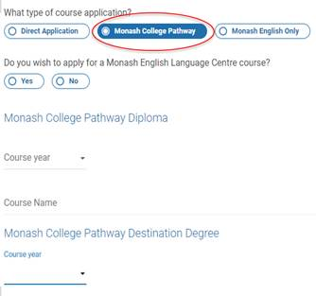

**To avoid delays:**

**For application fee,** when lodging an application, must include either**:**

* Evidence of application fee payment

OR

* Fee waiver code
* Be mindful when giving out fee waiver

**For additional docs & payments,**send them through the **New Message** function on agent portal to avoid having to put your email in a queue (Monash Admissions receive around 2000-3000 emails/day):

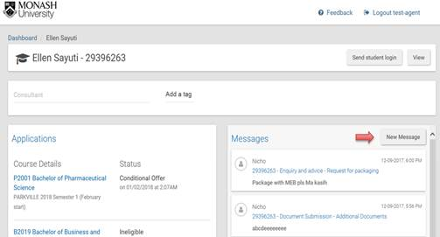

**Online Enrolment:**

Things to remember:

* Once student accepts their course, we’ll notify them to enrol in units online
* If the student’s acceptance is still conditional, the student will not be able to enrol until they have met and finalised their conditions.
* If the student is waiting for their credit assessment, they may still proceed with the online enrolment, they can change their units later.
* The latest date to enrol: Friday the week before class commencement, NON-NEGOTIABLE

Online Enrolment is at **Get Started website**:  <https://www.monash.edu/get-started?student=international>

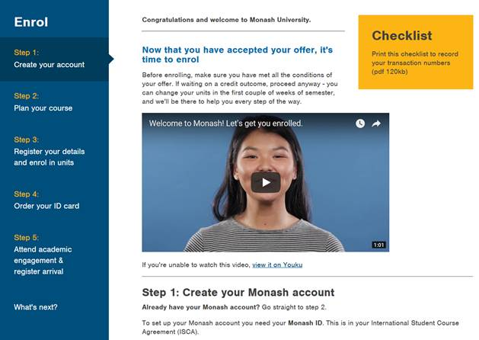

If a student require help or made a mistake in their online enrolment, go to **Get started website**, and refer to the **Need more help** section under Step 3.

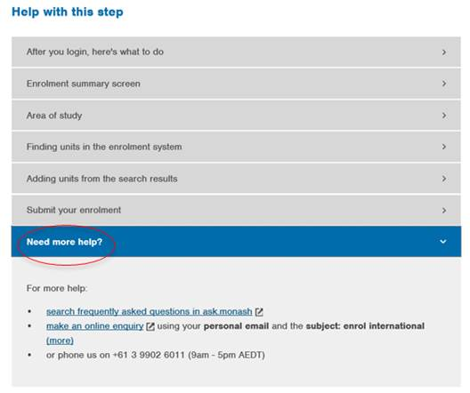

**Arrival Registration**: Student needs to register their arrival & collect their Monash ID card at Monash Connect

Latest date to register arrival: Friday last day of Orientation Week

To request a later arrival, email: [latereg@monash.edu](mailto:latereg@monash.edu)

•         Monash ID number

•         full name

•         Course

•         expected arrival date

•         reason for late arrival.

Approval to arrive late is not guaranteed

**Predicted Result:**

Monash accepts predicted result for *all* Monash undergraduate degree courses, *except* for Bachelor of Physiotherapy (Hons) and Bachelor of Medical Science & Doctor of Medicine from registered CIE GCE A Level and IB school.

Registered IB school that offers IB Diploma, refer to the following link: [http://www.ibo.org/programmes/find-an-ib-school/](http://www.ibo.org/programmes/find-an-ib-school/?SearchFields.Region=&SearchFields.Country=&SearchFields.Keywords=American+School+of+Bombay&SearchFields.Language=&SearchFields.BoardingFacilities=&SearchFields.SchoolGender=) (Note: in your search enter the school name in 'keywords' and ensure you click on Diploma Programme)

Registered CIE schools that offer CIE GCE A Levels, refer to the following link: [http://www.cambridgeinternational.org/i-want-to/find-a-cambridge-school/](http://www.cambridgeinternational.org/i-want-to/find-a-cambridge-school)

To be eligible for a full offer based on predicted AL or IB results:

* The actual results will not be available in time for study commencement
* the predicted results are provided in the form of a statement on the institution's letterhead, signed by the principal or registrar of the institution, or their authorised delegate no more than 3 months prior to the Monash University commencement date.  E.g. for Semester 2, 2018, commencement date is 23 July, therefore, the predicted result should be issued on 23th April at the earliest.
* The student predicted results is 2 points higher than the academic entry requirements
* The student has met the age requirement
* The student has met all course prerequisites (including English and extra requirements)

Notes:

* For predicted CIE GCE A Levels results**, the student needs to provide Monash Admissions their centre number and candidate number (generally made available to students in April and September of each year)**date of birth and series (i.e. when the final examination was taken)**.**
* For predicted IB results, students must provide their full name, date of birth and if available (however not compulsory) their alphanumeric IB student number and school session number. There's no need to submit IB Program Coordinator declaration form to submit predicted IB result.
* Predicted results can’t be used for those commencing their undergraduate studies in Semester 1, 2019.  To obtain a full offer, submission of a final official IB Diploma results or CIE A Level result is required.

**Calculating KKM (Kriteria Ketuntasan Minimal)**

To determine if a student meets Monash minimum score requirement: average all achieved scores in Semester 1 and 2 of the relevant academic year (e.g. SMA 2 for Diploma Part 1 & MUFY and SMA 3 for Diploma Part 2 & direct entry to undergraduate programs), both in Knowledge & Practical components, then use the KKM entry table.

If the KKM is varied from subject to subject, average all the KKMs from the relevant academic year to determine which KKM/passing mark is used on the table. If no KKM is stated on the academic transcripts, the student will need to provide a letter issued by the School stating what the KKM for the relevant academic year is.

**Monash English:**

The new Monash English entry requirement:

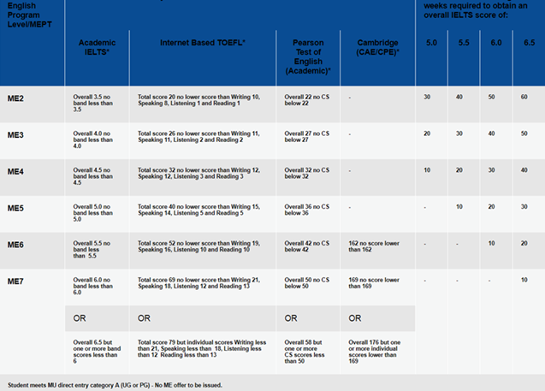

To calculate the number of Monash English Weeks required = Overall score + add 10 weeks if any one or more individual band / skill scores are lower.

Please note: Monash will not issue the offer letter for Monash English if the student already achieved the English Capability on Category A or above.