FAMTRIP REPORT
Name : Susanny
Institution : UTS – University of Technology Sydney
Date of Visit : 24 – 28 November 2015

- Institution Location
University of Technology Sydney is located in the heart of Sydney, one of the most multicultural cities in the world. The campus sits at the southern end of Sydney’s CBD- a national hub for global industries such as business, design, financial service , law , telecommunications and media. UTS is really city campus just 5 minutes’ walk to Central Station , 10 minutes by train to the Sydney Opera House and the Sydney Harbour Bridge , 10 minutes’ walk to cinemas , theatres ,cafes , markets and live music venues , 30 minutes by bus to Bondi beach , 90 minutes by train to the Blue Mountains. The address details is University of Technology Sydney , PO BOX 123 , Broadway – NSW 2007 Australia.

- Institution Environment And Facilities
The UTS campus is a vibrant, engaging and student friendly campus in the heart of Sydney- a place where students want to learn, study and socialize.

The Faculty of Engineering and IT Building ( New Building ) :
- State-of-the-art facilities
- Features a 3D data visualization arena
The Faculty of Science and Graduate School of Health Building ( New Building ) :
- New teaching, learning and research spaces
- Features a Super Lab , a vast , open laboratory ( 52m in length )
The Faculty of Business - Dr Chau Chak Wing Building ( New Building )
- Australia’s only Frank Gehry-designed building
- Home to UTS Business School

- General Entry Requirement
Undergraduate : IELTS 6.0 ( no band less than 6.0 ) / TOEFL 60-78 overall ( Writing 21)
Postgraduate : IELTS 6.5 ( no band less than 6.0 ) / TOEFL 70-93 overall ( Writing 21)

- Program Specific Entry Requirement
B of Arts Bachelor of Education / B of Arts Bachelor of Education (Hons) / Bachelor of Edu Bachelor of Arts in Int'l Studies
IELTS: 7.5 Overall ( speaking & listening 8.0 , reading & writing 7.0 )
TOEFL: 102 - 109 Overall ( speaking&listening&reading 23-27 ,writing 24 )
Bachelor of Design (Hons) in Animation/Bachelor of Arts (Hons) in Communications/Bachelor of Education (Hons) in Primary Education
IELTS : 7.0 Overall ( Writing 7.0 )
TOEFL : 94 - 101 Overall (Writing 23)
Bachelor of Nursing/Bachelor of Nursing Bachelor of Arts in International Studies
IELTS : 6.5 Overall ( Writing 6.0 )
TOEFL : 79-93 Overall ( Writing 21 )
All Engineering and Information Technology courses
IELTS : 6.0 Overall ( Writing 6.0 )
TOEFL : 60-78 Overall ( Writing 21 )
Master of Teaching in Secondary Education (excluding the Languages other than English major)
IELTS : 7.5 Overall ( Speaking&Listening 8.0 , Reading & Writing 7.0 )
TOEFL : 102-109 Overall ( Speaking&Listening&Reading 23-27 , Writing 24 )
Master of Advanced Journalism
IELTS : 7.0 Overall ( Writing 6.5 )
TOEFL : 94-101 Overall ( Writing 24 )
Graduate Diploma in Advanced Journalism
IELTS : 7.0 Overall ( Writing 6.5 )
TOEFL : 94-101 Overall ( Writing 24 )
Master of Pharmacy/Master of Pharmacy (International)
IELTS : 7.5 Overall ( all bands 7.0 )
TOEFL : 102-109 Overall ( reading&listening 24 , speaking 23,writing 27 )
Master of Clinical Psychology
IELTS : 7.0 Overall ( writing 7.0 )
TOEFL : 94-101 Overall ( writing 23 )

- Nearest International Airport and Environment
The nearest international airport is Kingsford Smith Airport , located 8 km (5 mi) or less than 1 hour to south of Sydney city centre, in the suburb of Mascot

- How to Travel from Nearest International Airport to Institution

# Free Shuttle Bus from UTS ( Available 2 weeks before orientation )

Just exit the Terminal 1 Arrivals Hall, turn left and look for the Royale Limousines Concierge desk at Arrivals Gate B located next to the Virgin Domestic transfer area and near the Travelex Currency Exchange. The concierge desk is open daily from 6am until 10pm.
All you will need to do is show the staff your passport to confirm you identity and a copy of your UTS CoE (Confirmation of Enrolment) to confirm your university place.

# Sydney Train
Take the train from Sydney Airport directly to the city for A$16.00. You will need to purchase an Adult Opal single trip ticket (opens an external site) as international students are not eligible for student transport concession, and fines apply. The last train departs Sydney International Airport train station at 11.48PM. From Central Railway Station, it’s five minutes’ walk to the UTS campus. All Sydney train lines connect at Central

# Taxi

Take a taxi, which will cost between A$15 and A$50 depending on where you travel to (or more if you are travelling beyond the inner city area).

- How to travel from the Largest City of the Country/State/Province to Institution

Student can take a bus or train to travel outside city centre

- Unique Selling Point
UTS offers practice-based learning in cutting-edge facilities. Students build their knowledge in a real world context through projects, group work and real-life case studies.

- City Environment and Entertainment
Sydney combines the downtown feel of a busy metropolis with a relaxed lifestyle. With its famous harbour, sandy beaches, national parks, and suburbs with their own unique identity, the city is in easy reach of places to explore.
Rated the fourth most liveable city for students in the world (QS Best Student Cities 2015), Sydney attracts over 35,000 international students to live and study in this culturally diverse city.
UTS’s central location means students can easily access Sydney attractions, entertainment and essential services from our campus doorstep.

- Indonesian Community (PPI)
http://ppi-australia.org/contact-us/

- Picture:
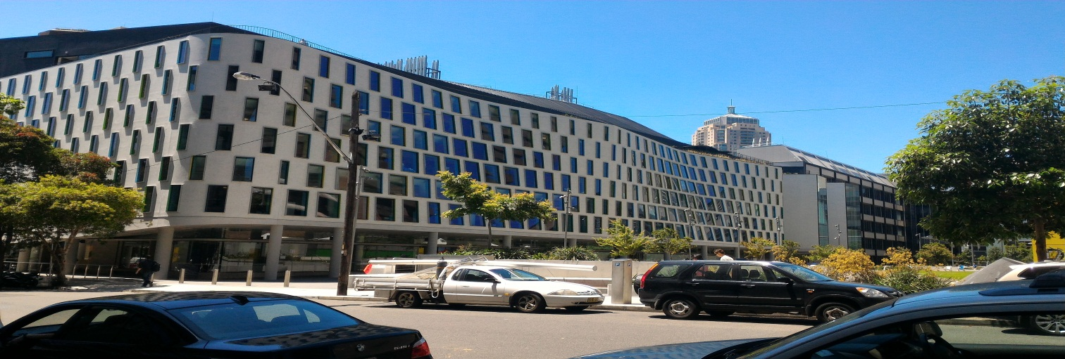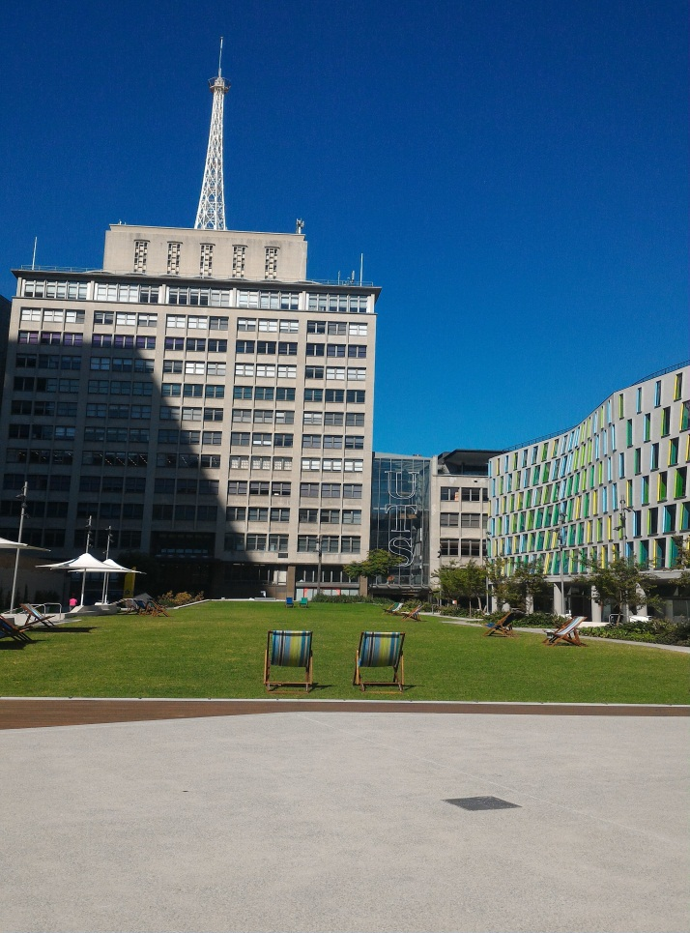
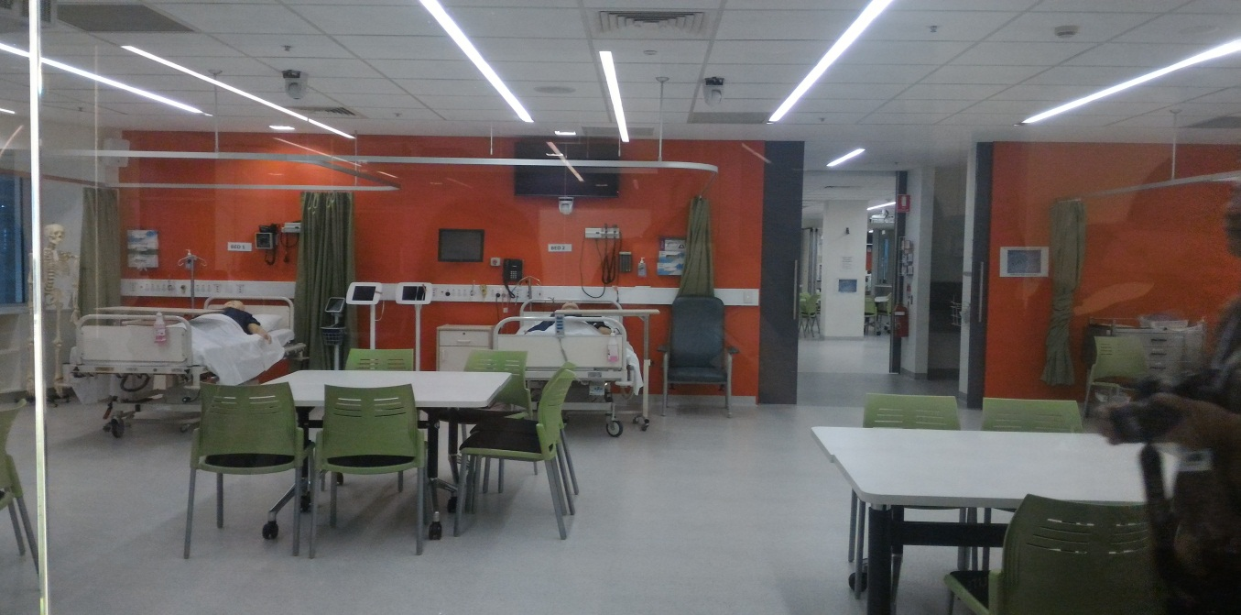

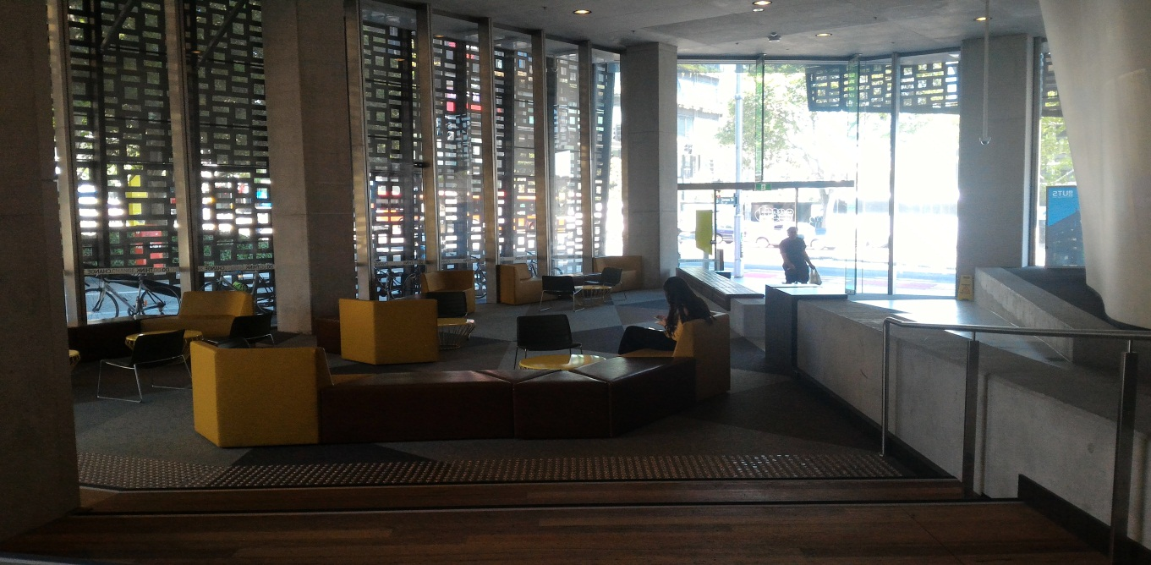

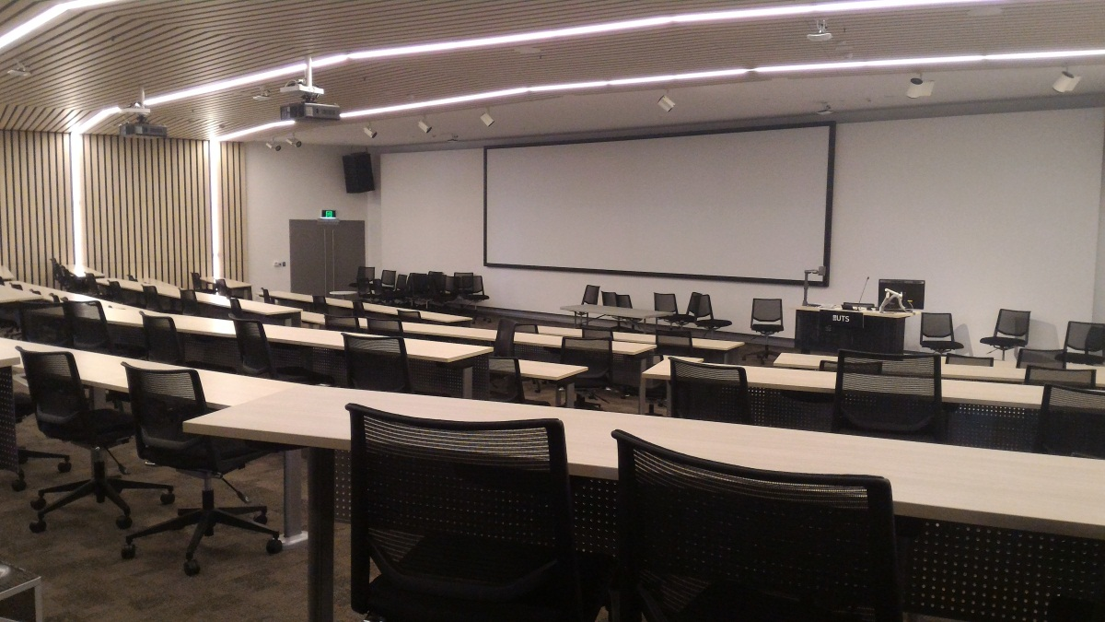
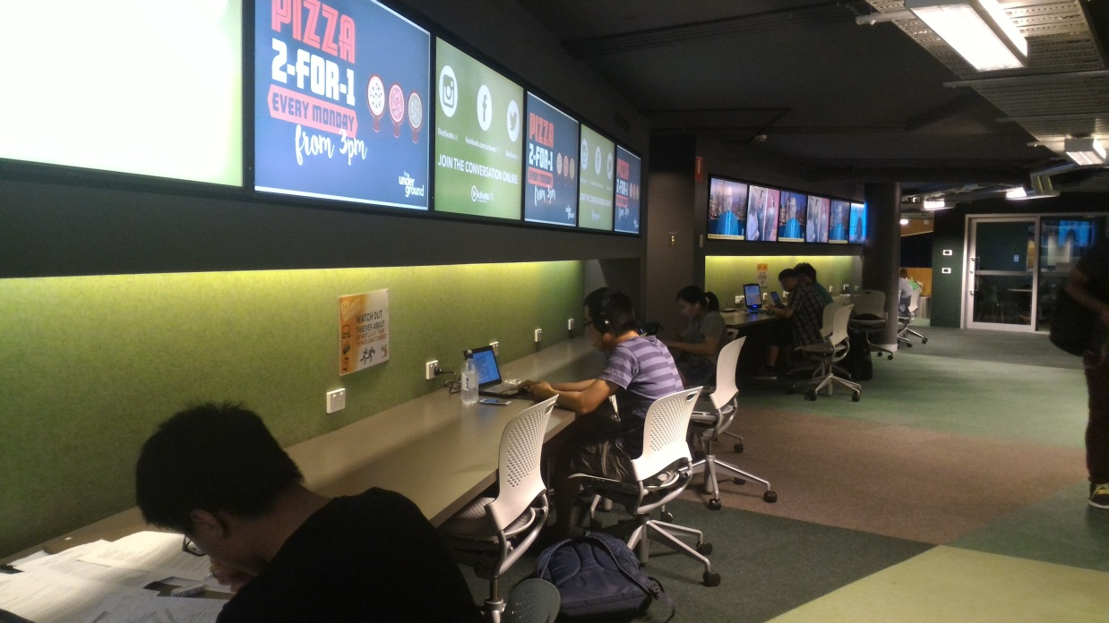

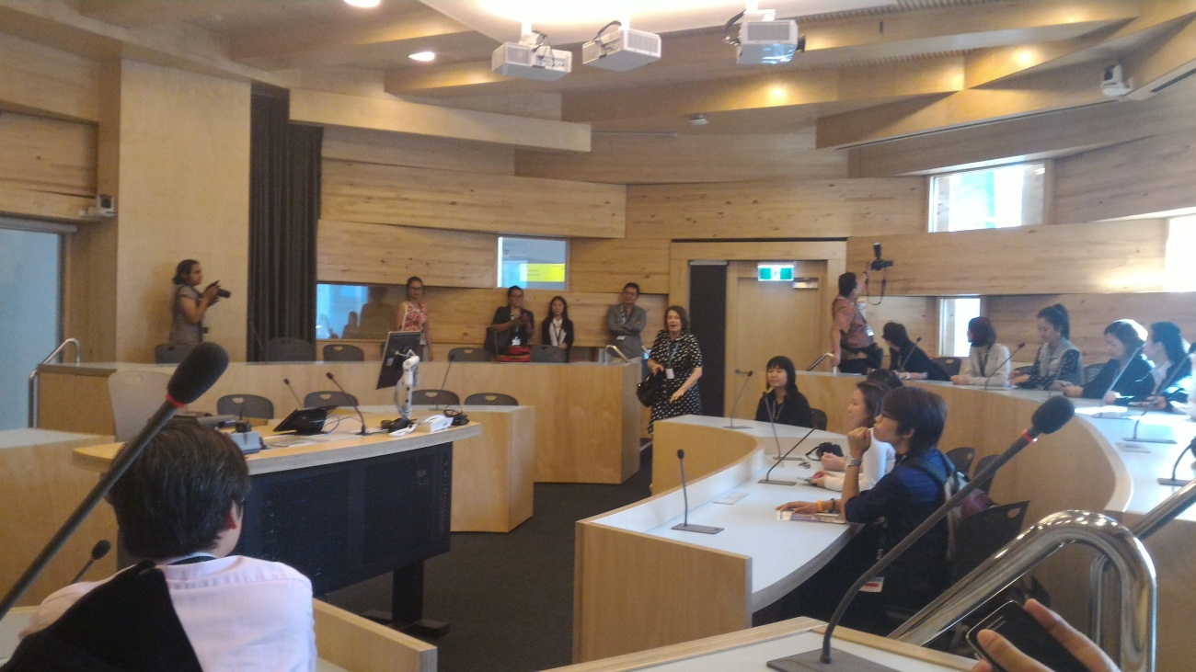

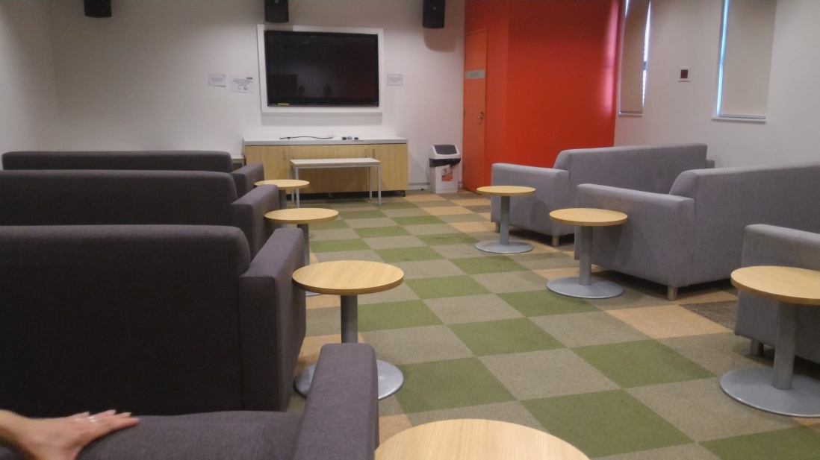
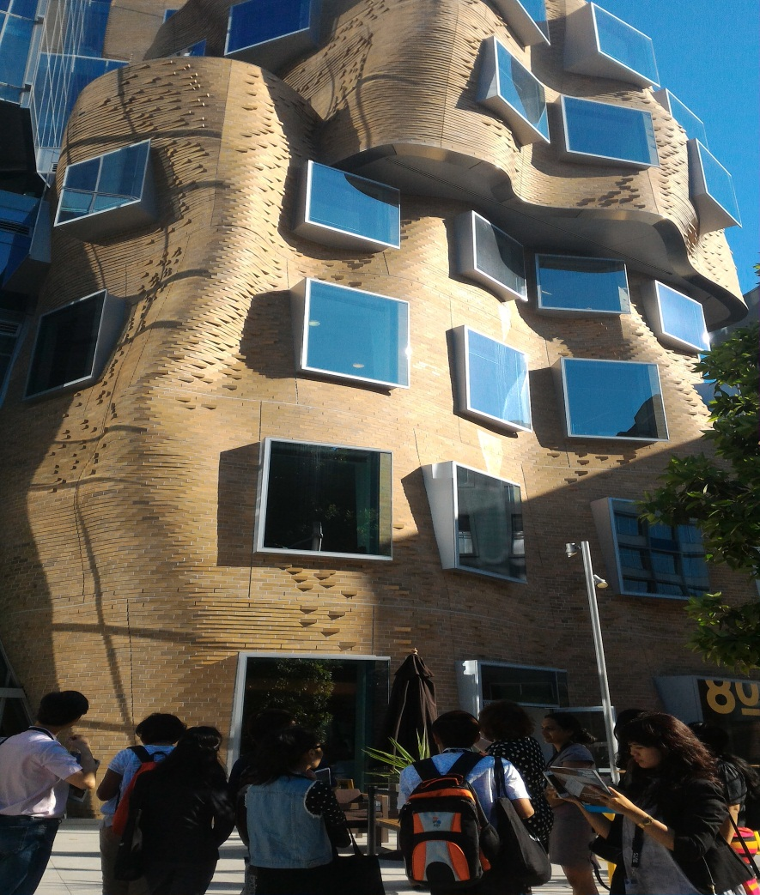

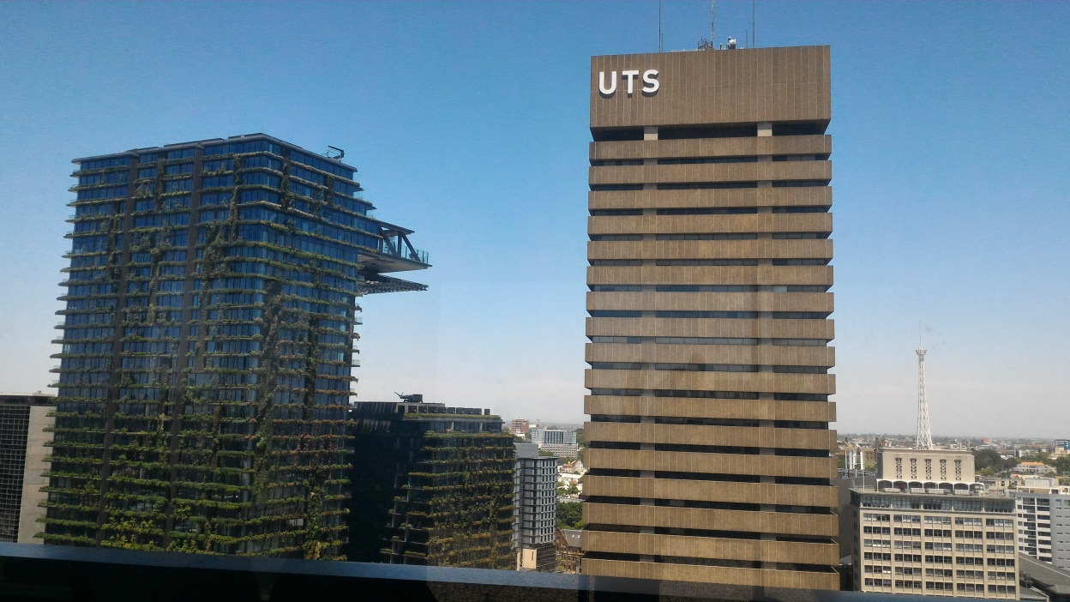

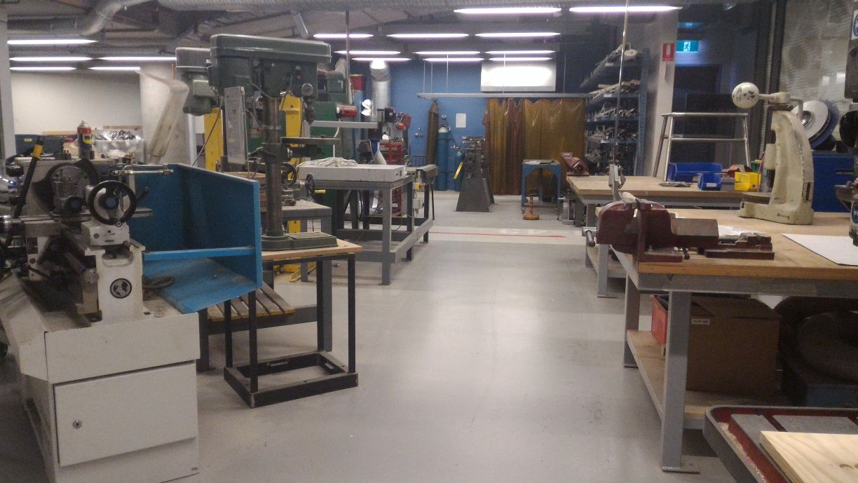

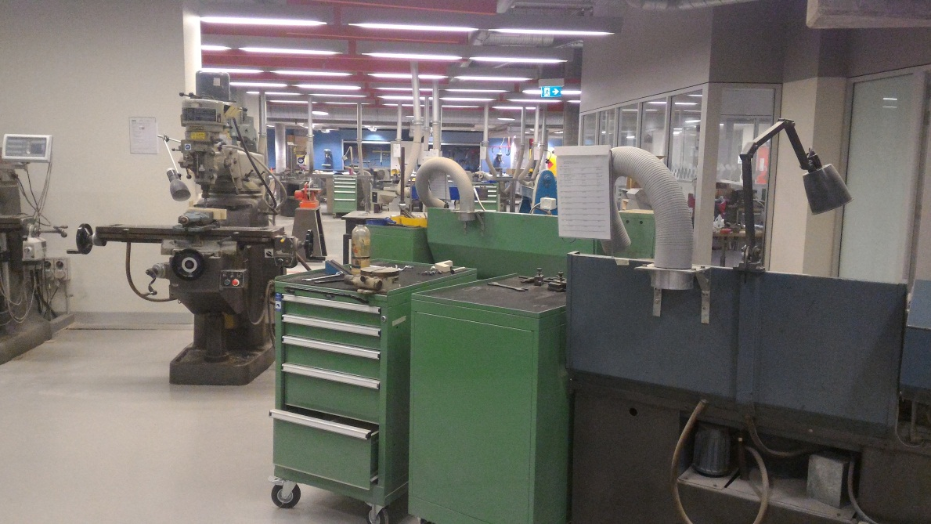

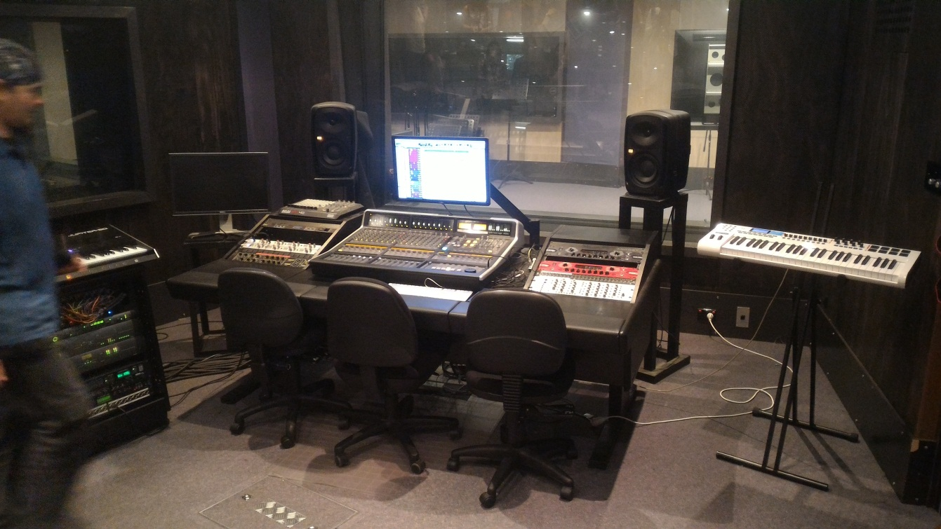

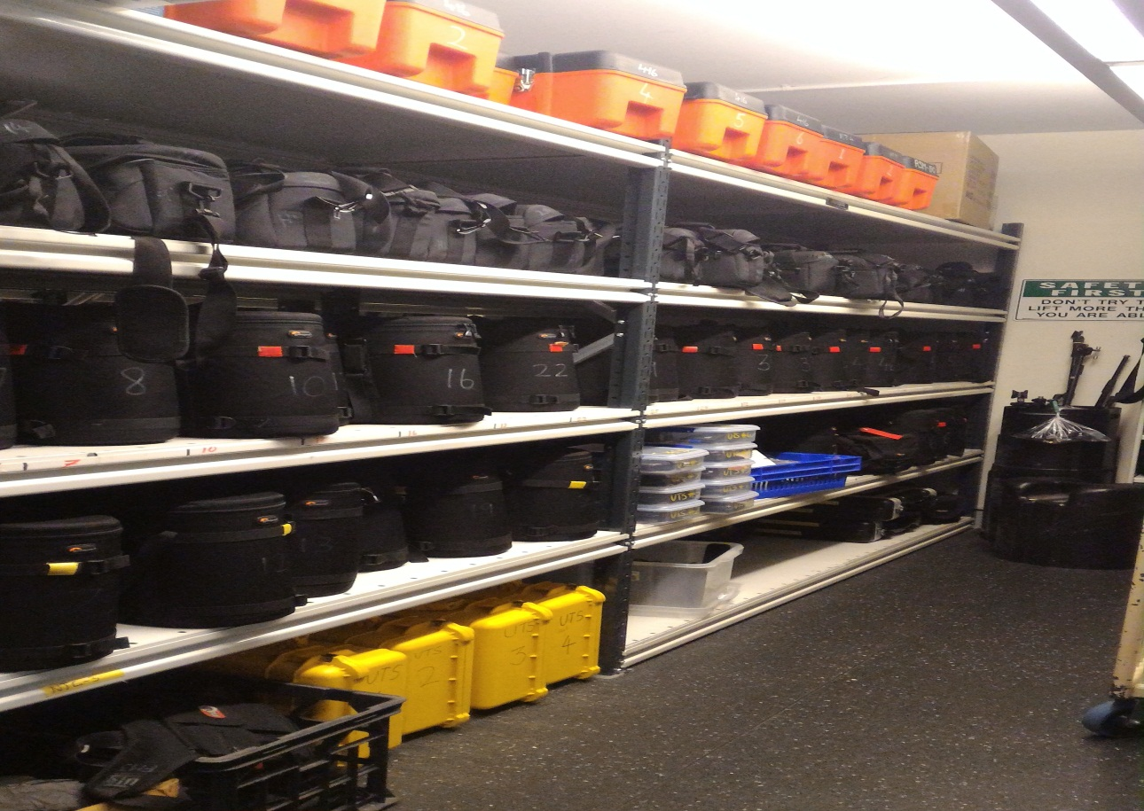

- Personal Experiences
It was a great experience to attend this agent conference from UTS. I love the campus with modern facilities inside and most of the lecturers and staffs so friendly , I can see that the environment very convenience for student to study and get a more experience with student from other country.

- Copy of Presentation
The copy for presentation it’s available on UTS USB.

